Ideation Phase Brainstorm & Idea Prioritization

Date | 25 may 2023
Team ID | NM2023TMID11390
Project Name | IOT based weather adaptive street lighting system
Maximum Marks | 04 marks

Brainstorm & Idea Prioritization Template:

We are brainstormed by analyzing the pattern to identify the different types of crime. The patterns may be the fatal or non-fatal weapon, situations and environment, positions of the non-fatal weapons, objects involved in the crime and the person involved in the images or video footages of the crime. Analyzing and identifying the victim and criminal from the images.

Step-1: Team Gathering, Collaboration and Select the Problem Statement
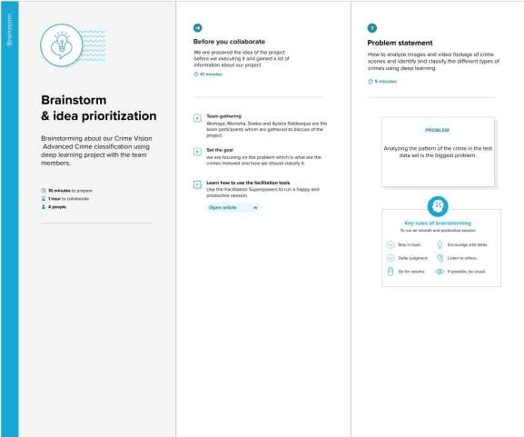

Step-2: Brainstorm, Idea Listing and Grouping
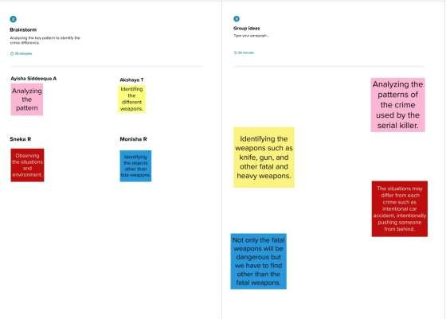

Step-3: Idea Prioritization

